**Project Proposal**

**on**

**Student Billing System**



**Tribhuvan University**

**Faculty of Humanities and Social Sciences**

**Bachelors in Computer Application**

**Submitted to**

**Department of Computer Application**

**Padmashree International College**

**Tinkune, Kathmandu**

|  |  |
| --- | --- |
| **Submitted by** | |
| KHESEHANG YONGHANG | KRISHNA DEV SAH |
| Year/Sem :- 2079 / Fourth Semester | Year/Sem :- 2079 / Fourth Semester |
| University Registration Number | University Registration Number |
| 6-2-22-324-2018 | 6-2-22-339-2018 |
| Exam Roll Number :- 220118 | Exam Roll Number :- 220133 |

# **Introduction**

Student Billing System (SBS) is a web-based application system, which will allow a greater student accounting experience. This application will allow to automate and digitalize all student account data, including payment, account management, and bill generation. SBS should be used by students to pay semester fees and view their remaining fees. The main aim of this system is to enable a smooth experience to all both students and account staffs.

A system database will store all the mentioned details and information about the college accounting side and the students. [1]

# **Problem Statement**

In Nepal, most of the governmental and even private educational institutions have a hard time providing a detailed information about the fees and associated expenses to the students, creating confusion to the students as well as their parents. Furthermore, it makes it hard to organize the student accounts.

# **Objectives**

This system will provide solutions to the problems faced by the students studying all around Nepal. Some of the objectives are:

* To provide easy access to the fee accounts to the students.
* To allow college to manage student accounts with more transparency.
* To provide the overall view of the entire financial program of the college to the students’ parents.

# **Scope**

The system is aimed at colleges and other educational institutions. Students and the accounting staffs of the college will have access to the system.

# **Methodology**

## **Requirement Identification**

### **Literature Review**

There are a few existing systems on the proposed system. Though the exact implementation isn’t there in the web, however a few similar systems are in existence. Freshworks is a tool that helps helps business owners to manage multiple sales, marketing, and customer support processes. According to its website, the organization provides a web-based solution for handling finances of its clients. Besides that, it provides many other features. [2]

Likewise, Sales Cloud also provides the feature of Sales Pipeline Management and account contact management, out of its other features. [3]

Zoho CRM also has implemented a similar system as the proposed one. This platform provides Customizable Sales Pipelines feature. [4]

### **Requirements Collection**

We decided to divide the requirements for this system in two different terms, one functional and another non-functional.

* **Functional Requirements.**

**For Students:**

* The system should allow students to register and login.
* The system should display what faculty and semester they belong.
* It should display the due amount to be paid and the overall fee structure.
* Students should be able to pay their dues via banks and other online fintech solutions, including Khalti, eSewa, IMEPay, and others.

**For Accounting Staff:**

* The system should create and manage student username and password.
* The system should display in which semester the students are studying and the amount they need to pay.
* The system should allow staffs to update the student accounts.

**For System Administrator:**

* The system should allow the system administrator to login and logout from the system.
* The system should allow the system administrator to add or delete details and information of staffs and students.
* The system should allow monitoring the system users (students and staffs) data.
* **Non- Functional Requirements.**

**Security**

Only the system admin has the right to the entire system. Other than him/her, students and staffs must pass through an authentication procedure to access the subsystems.

**Availability**

The system will be available for 24 hours as students can access it from anywhere

and at any time. However, the payment procedure will be dependent on whether the bank system is running or not.

**Performance**

The system will be fast and accurate. It will handle any expected or unexpected errors and also large amounts of data.

**Reliability**

The system will be reliable as it performs all the other functional and non-functional features without a failure. Further, its reliability is a must as the data is important and damages can cause incorrect or incomplete student details.

## **Feasibility Study**

### **Technical Feasibility**

As for the technologies for the proposed project, they all fall under the basic programming languages. Likewise, the libraries used are well understood and studied in previous semesters. All the used technologies are well documented in the web and provide a good base for the development and maintenance of the system.

### **Operational Feasibility**

Regarding the operation of the system, it will include all the functional and non-functional requirements and under all circumstances be operational. Speaking about operability of the system, the features will be completely operational and the users will be comfortable to use this system.

### **Economic Feasibility**

The system is economically feasible as we aren’t buying any specific hardware and hosting platforms. Furthermore, all the used technological tools are open source.

### **Schedule Feasibility**

The system which we are going to develop will be completed within scheduled time and will not exceed the scheduled time. [7]

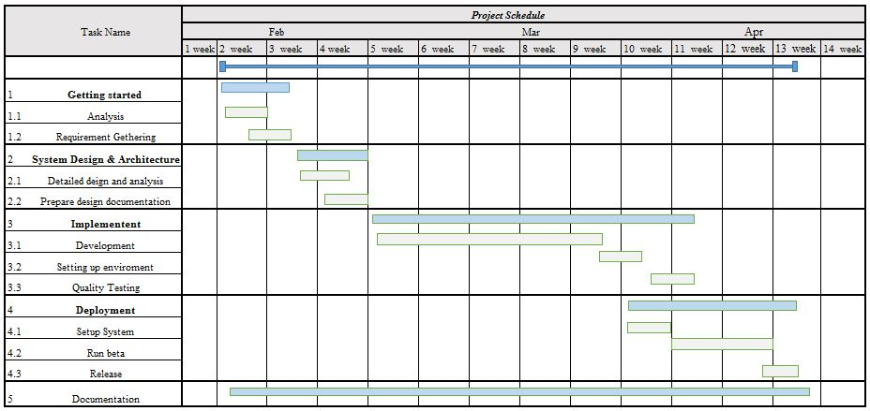

**Figure 1: Gantt chart for Sponsorship Management System**

## **High level Design of system**

### **System Analysis and Design**

**Data Modeling (ER-Diagram)**

In Entity-Relationship diagram there are five entities named administrator, applicant, sponsor, sponsor category and sponsorship. Admin has attributes like Admin id, name, password, email. Likewise applicant has Applicant id, name, password, email, phone and sponsor has attributes like Sponsor id, name, password, email, phone, category id. Sponsor category has attributes like category id, category name. Sponsorship has title, sponsorship id and amount. Admin can add and delete user and user can apply and posts for sponsorship.

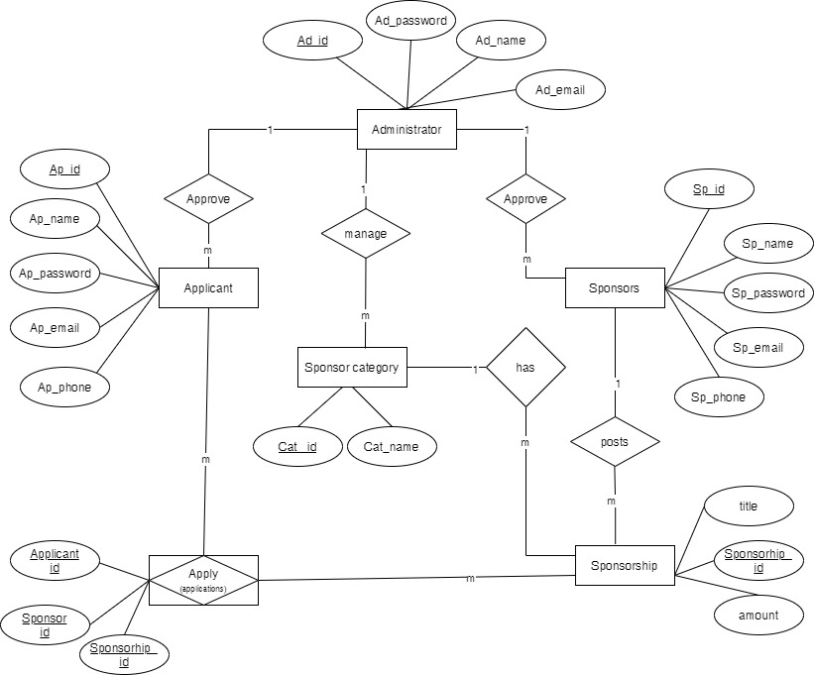

**Figure 2: Entity Relational Diagram for Sponsorship Management System**

**Process Modeling (DFD)**

Data Flow Diagram of Sponsorship Management System consists of two levels of DFD context diagram and level one dfd. Both these levels are used for making data flow diagram of SMS.

In context diagram, the login request, register, sponsor information are the inputs of SMS where users and admin request for login, users register, users enquiry about sponsorship and apply for sponsorship. The login response, details of sponsor and applicant are the outputs where admin and user get response about login success or cancel, admin get details of users and users get notification of sponsorship.

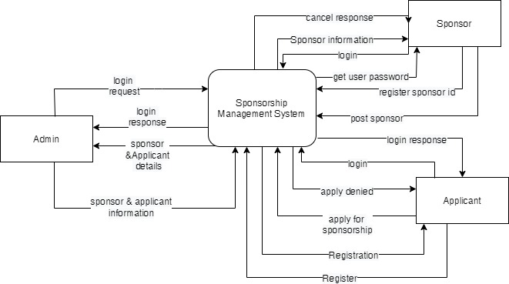

**Figure 3: level 0 DFD for Sponsorship Management System**

In level 1 DFD, there are five processes where for login, process 1 is responsible, for managing category of sponsor, process 2 is responsible likewise process 3, 4, 5 are for post sponsor, managing details of sponsor, applicant and for applying sponsorship. There are three entities admin, applicant and sponsor and four data stores are used in this level of DFD such as user details, category details, sponsorship, and applicant details.

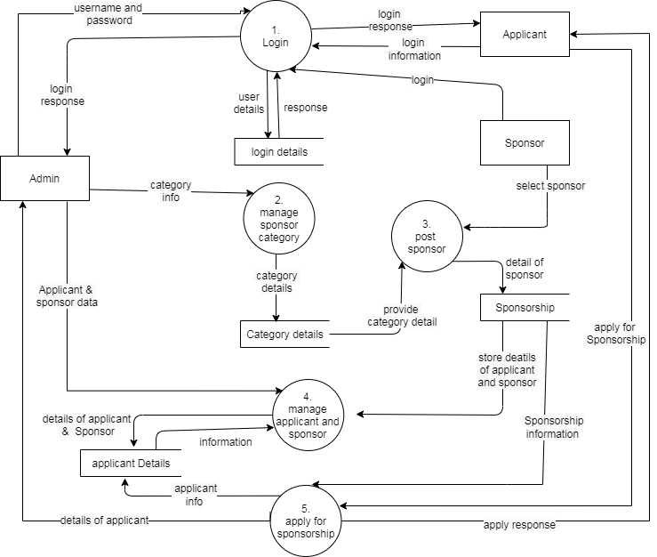

**Figure 4: Level 1 DFD for Sponsorship Management System**

### **System Development Tools**

* **Implementation Tools**

**Front end**

1. HTML (Hyper Text Markup Language)
2. CSS (Cascading style sheet)
3. Javascript
4. Bootstrap
5. jquery-3.5.1.min

**Back end**

1. PHP

**Database**

1. MySQL

# **Expected Outcome**

After the successful completion of the project, it will be expected to bridge of sponsor and needy people. This system will be able to manage the information and details of the applicants and sponsors and it will take less time to fill out applications. Users will be able to apply by logging in the website and they can get proper information about sponsorship in different categories and this system will show in which category sponsors are going to provide sponsorship.

# References

|  |  |
| --- | --- |
| [1] | "wiki.optimy," Sponsorship-management-software, 31 july 2017. [Online]. Available: https://wiki.optimy.com/sponsorship-management-software/. |
| [2] | "www.gov.uk," sponsor-management-system, [Online]. Available: https://www.gov.uk /sponsor-management-system. |
| [3] | "Child Nepal," [Online]. Available: https://www.childnepal.org/. |
| [4] | "children international," [Online]. Available: https://www.children.org/. |
| [5] | "tutorialspoint," [Online]. Available: https://www.ukessays.com/essays/ information-technology/methodology-the-waterfall-model-information-technology-essay.php? vref=1. [Accessed 14 02 2021]. |
| [6] | "tutorialspoint," [Online]. Available: https://www.tutorialspoint.com/ system_analysis_and_design/system_analysis_and_design_overview.htm. |
| [7] | "apm.org.uk," APM, [Online]. Available: https://www.apm.org.uk/resources/find-a-resource/gantt-chart/. |
| [8] | "Moveo," [Online]. Available: https://www.moveoapps.com/blog/web-application-development-guide/. |
| [9] | UkEassay, "UkEassay," 01 01 2015. [Online]. Available: https://www.ukessays.com /essays /information-technology/methodology-the-waterfall-model-information-technology-essay.php?vref=1. [Accessed 14 02 2021]. |
| [10] | M. H, "businessmanagementideas," [Online]. Available: https://www. businessmanagementideas .com /feasibility-analysis/feasibility-analysis-meaning-importance -report-types-process-objectives-and-advantages-business/18196. |